Bug_01:
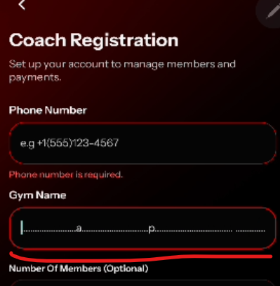
No validation
Bug_02:
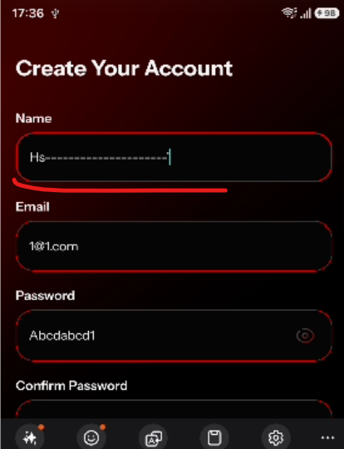
No validation error message
Bug_03:
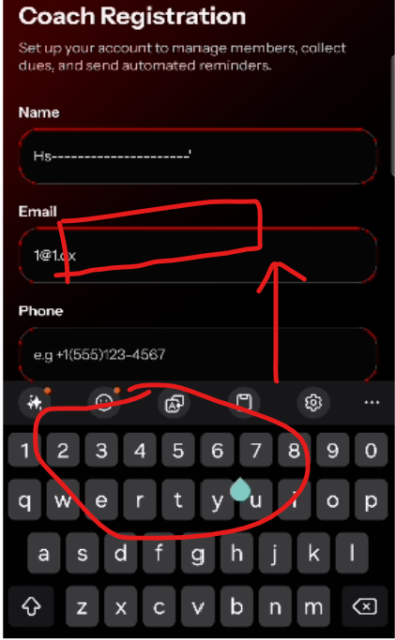
When try to add gym name, the fields disappear
when user click on field to enter name, the field should be visible to user

